CSRtrack Version 1.2
User’s Manual
M. Dohlus and T. Limberg

Contact:
Martin.Dohlus@desy.de / Torsten.Limberg@desy.de
Table of Contents

1. Introduction and Code Improvements 3
1.1. Changes in Version 1.1: 3
1.2. Changes in Version 1.2: 3
2. First Steps to run CSRtrack on a WINDOWS XP Computer 4
2.1. Download, Installation and a First Run 4
2.2. The Example Input (File) 5
2.3. Plotting Results 9
2.4. Calculation of the example with other models for the CSR fields (‘forces’) 11
2.4.1. With Force Type p_to_p 11
2.4.2. With Force Type g_to_p 11
2.5. Typical CPU Time and File Structure for the Example 12
3. CSRtrack Command Structure 13
3.1. Command File 13
3.2. Sections 13
3.3. Global Commands 13
4. CSRtrack Sections 14
4.1. Section: io_path 14
4.2. Section: lattice 14
4.2.1. Definition of Field-Boundaries (Subsection: position) 16
4.2.2. Branch Section: Dipole 17
4.2.3. Branch Section: quadrupole 18
4.2.4. Branch Section: multipole 18
4.3. Assignment Section: particles 20
4.4. Section: track_step 23
4.5. Section: tracker 28
4.6. Section: forces 30
4.6.1. Introduction to the Different CSR Models 31
4.6.2. Parameters for the projected Force 31
4.6.3. Parameters for the csr_p_to_p and csr_g_to_p Forces 33
4.6.4. Additional Parameters for the csr_p_to_m and csr_g_to_m Forces 34
4.6.5. Shielding 34
4.6.6. Setting Sub-bunch Sizes from File 35
4.6.7. Examples 36
4.7. Sections: monitor and online_monitor 36
4.7.1. online_monitor: type=phase 38
4.7.2. online_monitor: type = subbunch 41
4.7.3. online_monitor: type = steps 41
5. Appendix 42
5.1. CSRtrack Units 42
5.2. Results for Example Case 42
5.3. Example for Position Averaging Pulse Smoothing Technique 44
5.4. Fixed Bugs 45
6. Bibliography 45

Introduction and Code Improvements
The CSRtrack code tracks particle ensembles through beam lines with arbitrary geometry. The field calculation in CSRtrack offers different algorithms to choose from, from the fast ‘projected’ 1-D method to the most rigorous, the three-dimensional integration over 3D Gaussian sub-bunch distributions (see section ‘forces’).
The 3D field calculations take Coherent Synchrotron Radiation fields into account as well as intra-bunch fields, similar to the well-known space-charge fields on straight trajectories, but, on curved paths, not cleanly separable from radiative fields any longer.
Tracking is done in absolute coordinates through a magnet lattice defined by magnet field boundaries (see section ‘lattice’) using a self-consistent algorithm. CSRtrack handles dipole, quadrupole and multipole magnets.
RF sections are not implemented yet. Tracking through long straight RF sections is better left to codes like elegant or ASTRA, depending on the importance of space charge force.

Changes in Version 1.1:
New types of CSR field calculation methods:
- csr_p_to_m
- csr_g_to_m
(see section ‘forces’). The forces are calculated using meshed electromagnetic field values which is useful when tracking big numbers of particles since the cpu time scales linear (and not quadratically) with the number of particles.

Changes in Version 1.2:
- Current smoothing for ‘projected’ force with a Gauss filter and position averaging.
- Added the possibility for the force type ‘projected’ to introduce a user defined wake field to model for instance the resistive wake of a magnet chicane vacuum chamber.
- Bug fix for self-force of type projected (see appendix).

First Steps to run CSRtrack on a WINDOWS XP Computer

Download, Installation and a First Run
Download the file ‘CSRtrack_example1.zip’ from
http://www.desy.de/xfel-beam/csrtrack/index.html
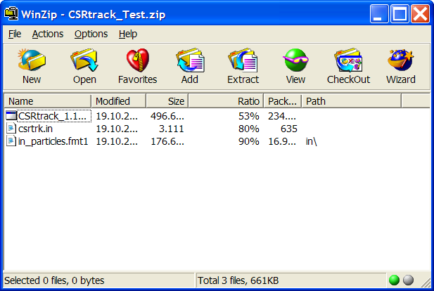
and open it. You should see the following window:

Extracting all files into a new folder (called ‘CSRtrack_Test’ here) should lead to the following if you explore the folder:
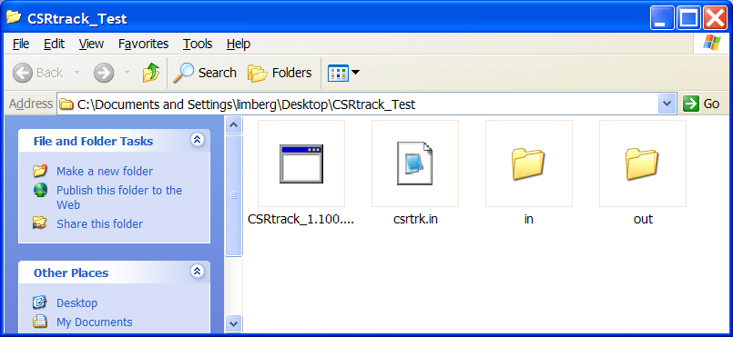
The folder ‘in’ contains the particle distribution file ‘in_particles.fmt1’ (see section ‘particles’), the ‘out’ folder is empty. The CSRtrack executable expects to find a ‘csrtrk.in’ file in the same folder it is located. That file can be a complete description of the run or it may refer to other input files (see ‘Command File’).
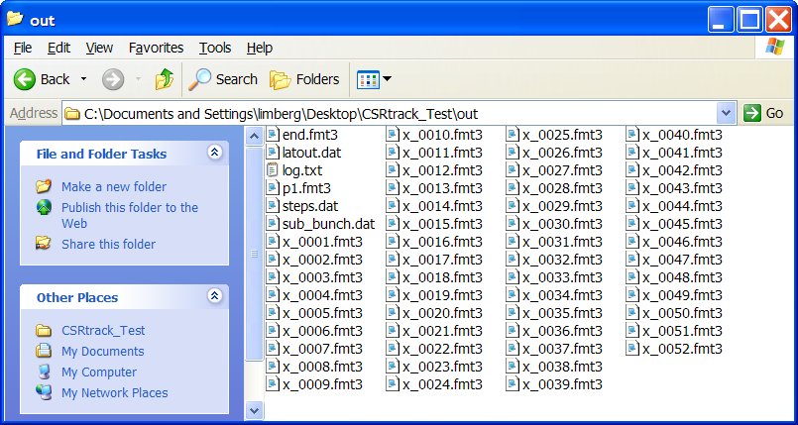
Double-clicking the executable runs CSRtrack and the following files should appear in the ‘out’ folder:

Now you ran CSRtrack successfully for the first time. For a better understanding what you calculated and how the output is generated, let’s look into the ‘csrtrk.in’ file.

The Example Input (File)
It starts with the specification of in- and output paths (see section io_path), starting the path in the folder where the executable is located.
!---------------------------------------------------
io_path{input =in,output=out,logfile=log.txt}

So our folders ‘in’ and ‘out’ are specified as targets for in- and output.
Now the lattice is defined (see section ‘lattice’):
!---------------------------------------------------
! 4 magnet bunch compressor
!---------------------------------------------------
lattice{
dipole ! 1st dipole
{position{rho=0.0,psi=0.0,marker=d1a}
properties{r=-8.4}
position{rho=0.5,psi=0.0,marker=d1b}
}
dipole ! 2nd dipole
{position{rho=1.0,psi=0.0,marker=d2a}
properties{r=8.4}
position{rho=1.5,psi=0.0,marker=d2b}
}
dipole ! 3rd dipole
{position{rho=2.5,psi=0.0,marker=d3a}
properties{r=8.4}
position{rho=3.0,psi=0.0,marker=d3b}
}
dipole ! 4th dipole
{position{rho=3.5,psi=0.0,marker=d4a}
properties{r=-8.4}
position{rho=4.0,psi=0.0,marker=d4b}
}
}

And describes a four dipole magnet chicane

with the following parameters:
chicane
bend magnet length (projected) | 0.5 m
drift length,(proj.) B1->B2 and B3->B4 | 0.5 m
drift length, B2->B3 | 0.5 m
bend radius | 8.4 m
momentum compaction | 6 mm

The particles distribution to be tracked is specified next:
!---------------------------------------------------
! particle distribution
!---------------------------------------------------
particles{reference_momentum =reference_particle
reference_point_x =0.0
reference_point_y =0.0
reference_point_phi =0.0
format=fmt1,array=#file{name=in_particles.fmt1}
}
After some options to change the reference system, the distribution is referenced to the file we have already seen in the ‘in’ folder. The format is ‘fmt1’ in this case (see section ‘particles’).
The example consists of a Gaussian particle distribution (~1000 particles). Beam parameters are:
bunch
energy | 511 MeV
charge | 0.833 nC
bunch length (in) | 80 µm
bunch length (out) | 20 µm
peak current (out) | 5 kA
horizontal twiss parameters (in):
normalized emittance | 1 mm mrad
alpha | 2.2
beta | 10 m
particle distribution
number of particles | 997
number of slices | 83
particles per slice | 12
reference particle without charge
sub-bunch length | 5.3 µm
sub-bunch width (horizontal) | 33 µm
sub-bunch width (vertical) | 50 µm

The output of CSRtrack is prompted by so-called monitors: ‘Online monitors’ write data to file during the tracking, ‘offline monitors’ save data at the beginning or the end (see ‘monitor’)
!---------------------------------------------------
! online monitors
!---------------------------------------------------
online_monitor{name=sub_bunch.dat,type=subbunch
start_time_c0=now
end_time_marker=d4b,end_time_shift_c0=2.0
time_step_c0=all
}
online_monitor{name=steps.dat,type=steps
start_time_c0=now
end_time_marker=d4b,end_time_shift_c0=2.0
time_step_c0=all
}
online_monitor{name=p1.fmt3,type=phase,format=fmt3,particle=1
start_time_c0=now
end_time_marker=d4b,end_time_shift_c0=1.0
time_step_c0=all
}
online_monitor{name=x.fmt3,type=phase,format=fmt3,particle=all
start_time_c0=now
end_time_marker=d4b,end_time_shift_c0=1.0
time_step_c0=0.10
}

!---------------------------------------------------
where name specifies the file name(s) to write the data to, accordingly the files named ‘sub_bunch.dat’ etc. appear in our ‘out’ folder. Details can be found in the section ‘monitor’; in the example above data describing sub-bunch length, time-step-width and the phase-space position of the reference particle along the beam-line are dumped in single files while the x_n files contain the phase-space coordinates for all particles at positions 10 cm apart from start to end_time_marker+end_time_shift _c0 [m].
The method to calculate CSR fields and the parameters of the sub-bunches are chosen in the ‘forces’ command:
! force definition
!---------------------------------------------------
forces{type=projected
sigma_long= 5.3e-6
}
In this example, the 1-D projected field calculation method is used with a longitudinal size of 5.3μm. See chapter ‘forces’ for details and other field solvers.
Finally, the range for the tracking calculation and the numerical parameters for the self-consistent, iterative particle tracking are specified:
!---------------------------------------------------
! tracking
!---------------------------------------------------
track_step{precondition=yes
iterative=2
error_per_ct=0.001
error_weight_momentum=0.0

ct_step_min=0.02
ct_step_max=0.10
ct_step_first=0.10
increase_factor=1.5
arc_factor=0.3
duty_steps=yes
}

tracker{end_time_marker=d4b,end_time_shift_c0=1.00}
The ‘track_step’ command specifies that iterative tracking will be performed until two iterations are done or the error criterion is reached. The parameter ct_step_min and the ones below control the step-width algorithm. For details see section ‘track_step’.
The ‘tracker’ command tells the code to track to the marker ‘d4b’, which is associated with the end of the last bend (see the lattice definition above) plus an additional time interval which corresponds to the reference particle traveling the length of 1 m with speed c0 (end_time_shift_c0=1.00). For details see section ‘tracker’.
Finally, another monitor command writes the phase space at the end of the tracking to the file ‘end.fmt3’:

!---------------------------------------------------
! offline monitors
!---------------------------------------------------
monitor{format=fmt3,name=end.fmt3}
The calculation is started by running CSRtrack in the directory with the input file. The particle distribution is read from in/particles_in.fmt1 and all output files are written to the directory out. This should create the same files as in the folder out_solved.

Plotting Results
A MATLAB GUI called ‘CSRtrack_ps_viewer’ is available to plot CSRtrack results. Download the file ‘ps_viewer.zip’ and extract the files in a folder ‘ps_viewer’. Open MATLAB, choose that folder as working directory and enter ‘ps_viewer’ on the MATLAB command line. You should see the following GUI:
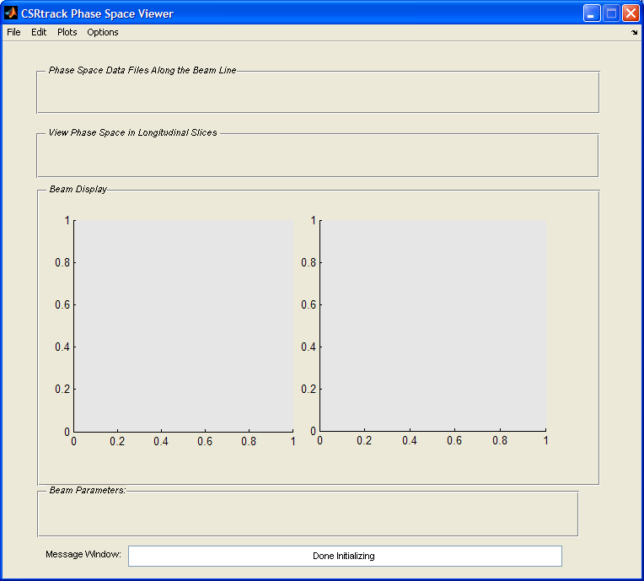
Basically there are two axes to plot phase space projections for comparison. Use the ‘File’ pull-down menue and choose ‘open’ to open one of the result files you have in the ‘out’ folder in your CSRtrack_test folder. The browse window should show the following files:
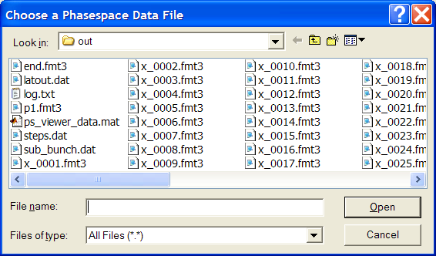
The ps_viewer reads phase space distributions saved in the CSRtrack formats .fmt1 (like the input file) or .fmt3. Open the x_0001.fmt3 file and the longitudinal phase space at this position will appear, after a message box
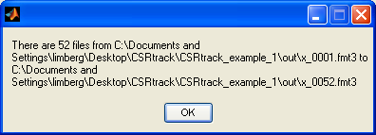
has informed you that there are 52 files along the beam line. A ‘Movie’ button pops up when there are more than 3 files of such type and you can push it to see a movie of how the longitudinal phase space evolves along the chicane.
The slider or the editing field can be used to go back and forth between the different x_nnnn files): Here the longitudinal phase of file #41 is displayed. A warning came up to tell you that all the particles of the bunch are in the same bin. The ps_viewer automatically bins the particles in longitudinal slices and analyses the slices. The results can be displayed if the ‘Slice’ button is pressed. The default slicing is done so that 1000 particles are contained in a slice, and the example data sets have 996. Use the ‘Options’ pull-down menu and go to ‘Plotting Options’ and then to ‘General Plot Options’ to reduce that number to say a hundred and press ‘Slice’ and look through the slices. Press ‘Slice’ again and you are back to the overall view.
If you click on the other, right, window, it will change to white and indicate thereby that it is the active axes. Load the same file into this axes and display the horizontal phase space using the pull-down menus of the axes: hor for horizontal and p_hor for normalized horizontal momentum.
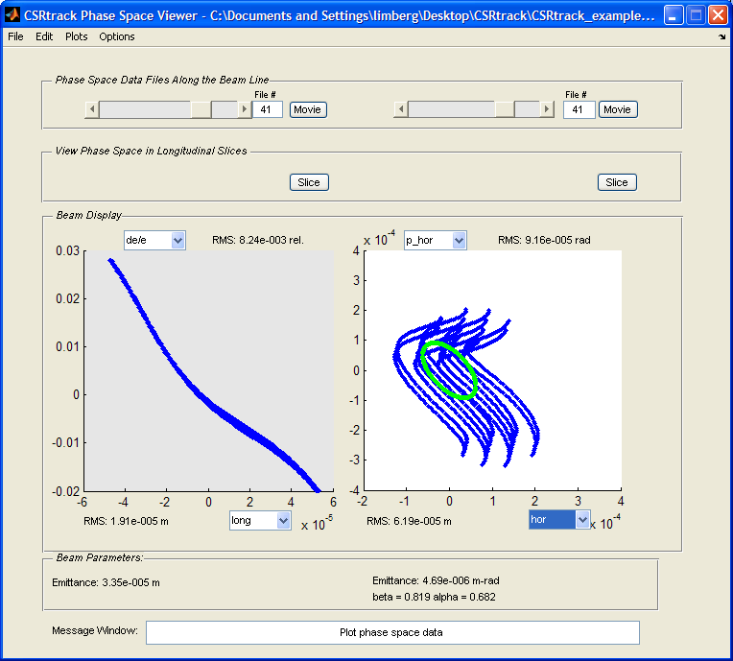
When ‘normal’ transverse phase space (like x-xp) is plotted, the emittance and the optics is calculated, else only the RMS values. The green line is the usual Twiss parameter ellipse.
Two things should be pointed out here: the regular distribution of the particles – necessary if a calculation with only a thousand particles is not completely to be dominated by artificial noise – and the strong distortion phase space can undergo in the presence of CSR fields which make its interpretation by looking at projections difficult.

Calculation of the example with other models for the CSR fields (‘forces’)

With Force Type p_to_p
The command file is the same as for force type = projected with exception of the force definition:
!---------------------------------------------------
! force definition
!---------------------------------------------------
forces{type=csr_p_to_p,shape=ellipsoid
sigma_long= 5.3e-6
sigma_rad =33.0e-6
sigma_vert=50.0e-6
}

With Force Type g_to_p
The command file is the same as for force type = projected with exception of the force definition:
!---------------------------------------------------
! force definition
!---------------------------------------------------
forces{type=csr_g_to_p,shape=ellipsoid
sigma_long= 5.3e-6
sigma_rad =33.0e-6
sigma_vert=50.0e-6
}

The dimensions of the sub-bunches are summarized in the following table.
Sub-Bunch Dimensions
sub-bunch length | 5.3 µm
sub-bunch width (horizontal) | 33 µm
sub-bunch width (vertical) | 50 µm

Results for the calculations with the different force types are plotted in the appendix.

Typical CPU Time and File Structure for the Example
Calculation time (on a PC from 2004) for the projected method is less then 1minute, for the g_to_p method 30 minutes and for the ‘direct’ p_to_p method 8.5 hours.
examples
projected
csrtrk.in
in
in_particles.fmt1
out
out_solved
log.txt
latout.dat
sub_bunch.dat
steps.dat
x_0001.fmt3 … x_0052.fmt3
end.fmt3
g_to_p
csrtrk.in
in
out
out_solved
p_to_p
csrtrk.in
in
out
out_solved

CSRtrack Command Structure

Command File
CSRtrack reads all commands from the ascii input file ‘csrtrk.in’. It has the following structure:
commands exit <CR>
with
commands = command [commands]
command = comment / global_command / section
comment = ! text <CR>
separator = <blank> / , / <CR>
The input file can be used to specify and open further input files (see #file). The length of command lines in input files is limited to 400 characters.

Sections
section_name { section_body }
A section-call causes three activities:
1) The section is initialized after the opening bracket ‘{’,
2) Global commands and specific section commands are valid in the section body. Section specific commands are either assignment statements or nested sections. The assignment of section parameters can be done in any succession. The only exception is the particles definition (see section particles).
3) The section action is started after the closing bracket ‘}’.

Global Commands
There is only one global command in version 1.0:
global_command = #file{name = filename}
filename = < name of nested input file >
The #file command opens a nested input file. The commands in this file are processed in the same way as that in the command file ‘csrtrk.in’. Maximal 10 nested files can be opened at once. Each nested file has to end with <CR>. After the processing of a nested file, CSRtrack continues processing of commands in files with higher level or of commands in ‘csrtrk.in’.
CSRtrack searches the input file filename either in the root directory (with ‘csrtrk.in’) or, if specified, in the input directory that is defined by the section iopath.

CSRtrack Sections
section name
io_path | file io
lattice | lattice definition
particles | definition of particle distribution
track_step | Time grid, iterative tracking
tracker | tracking
forces | model for self forces
monitor | monitor
online_monitor | online monitor

Section: io_path
The io_path section is used to specify the input- and output-directories. If these directories are unspecified, input- and output-files are read from or written to the root directory (with ‘csrtrk.in’).
identifier | argument | unit / type
input | input directory | character string
output | output directory | character string
logfile | file name | character string
Example:
io_path{input =data/bc2/in,
output =data/bc2/out,
logfile=log.txt}
has the same effect as:
io_path{logfile=log.txt,
input =data/bc2/in,
output =data/bc2/out}
The logfile is written to ‘data/bc2_100/out/log.txt’.

Section: lattice
subsection name
dipole | definition of dipoles
quadrupole | definition of quadrupoles
multipole | definition of multipoles
- Concept: CSRtrack supports magnetic dipole- and multipole-fields that are defined in specified (x,y,z) coordinates. The range of these fields is defined by two field-boundaries that are perpendicular to the xy-plane. The dipole field between field boundaries is constant and parallel to the z-axis. Together with the dipoles a reference trajectory is defined that is composed by arcs and lines and lies in the xy-plane. The first part of the reference trajectory coincides with the x-axis. The definition of each lattice element has three parts: the definition of the first field-boundary, the definition of element properties and the definition of the second field boundary.

- Example:
lattice{
dipole ! 1st dipole
{position{rho=0.0 ,psi=0.0,marker=d1a}
properties{r=-1.66275}
position{rho=0.5 ,psi=0.0,marker=d1b}
}
dipole ! 2nd dipole
{position{rho=1.0 ,psi=0.0,marker=d2a}
properties{r=1.66275}
position{rho=1.5 ,psi=0.0,marker=d2b}
}
dipole ! 3rd dipole
{position{rho=2.463,psi=0.0,marker=d3a}
properties{r=1.66275}
position{rho=2.963,psi=0.0,marker=d3b}
}
dipole ! 4th dipole
{position{rho=3.463,psi=0.0,marker=d4a}
properties{r=-1.66275}
position{rho=3.963,psi=0.0,marker=d4b}
}
}

Definition of Field-Boundaries (Subsection: position)
identifier | argument | unit / type
rho | value | length / number
psi | value | angle /number
delta_s | value | length / number
delta_psi | value | angle / number
marker | marker name | character string
duty | yes / no
The position section is used to define field-boundaries. They can be defined absolute or relative.
- Absolute definition of field boundaries: The field boundary is defined in polar coordinates by the parameters rho and psi. The definition of the first field boundary has to be absolute. The reference trajectory before the first field boundary is identical to the x-axis. The first reference point is the intersection of the first reference plane and the x-axis. The rest of the reference trajectory (and all later reference points) are recursively defined by dipoles and their curvature radii.
- Relative definition of field boundaries: If the position and direction of the reference trajectory are defined for one field boundary, the position and direction of the intersection with the next field boundary is uniquely defined by the path-length difference delta_s and the curvature radius r (if a dipole is bounded). The orientation of the field boundary is either specified by psi or delta_psi or it is perpendicular to the reference trajectory. Psi defines the absolute orientation (in the same way as for the absolute definition) and delta_psi defines the angle between field boundary and the plane perpendicular to the trajectory at the intersection point.
- marker: The identifier marker is used to assign a name to a field boundary. The marker names can be used to specify time events eg. The instantaneous time when the reference particle (see particle definition) passes a field boundary. This identifier is optional, its argument is a character string.
- duty: The identifier duty can be used to affect the step width control of the tracking algorithm (see track_step). This identifier is optional, its argument is yes or no. If duty is not specified, it is set to yes for field boundaries of dipoles and to no for the rest.
- Example
position{delta_s=0.2,marker=quad_in,duty=no}

Branch Section: Dipole
subsection name
position | definition of field boundaries
properties | dipole properties
- Subsection position: See ‘Definition of Field Boundaries’.
- Subsection properties:
identifiers | argument | unit / type
r | value | length / number
r sets the curvature radius of the reference trajectory. In combination with the reference momentum (see particles) the strength of the dipole field is uniquely determined. To take into account vertical effects (z-direction) by edge 19pecifie, the tracking algorithm applies a vertical kick proportional to the offset from x-y-plane at the field boundaries.
- Example:
dipole ! 1st dipole
{position{rho=0.0 ,psi=0.0,marker=d1a}
properties{r=-1.66275}
position{rho=0.5 ,psi=0.0,marker=d1b}
}

Branch Section: quadrupole
subsection name
position | definition of field boundaries
properties | quadrupole properties
The definition of quadrupoles is identical to that of multipoles that is described in the next subsection. The only difference is the parameter poles that obsolete. Example:
quadrupole{ position{delta_s=0.2,marker=quad_in,duty=no}
properties{strength=0.100,alpha=0
horizontal_offset=0,vertical_offset=0}
position{delta_s=0.5,marker=quad_out,duty=no}
}

Branch Section: multipole
subsection name
position | definition of field boundaries
properties | multipole properties
- Subsection position: See ‘Definition of Field Boundaries’.
- Subsection properties:
identifier | argument | unit / type
strength | value (a) | length^(−n) / number
alpha | value (α) | angle / number
horizontal_offset | value (h₀) | length / number
vertical_offset | value (v₀) | length / number
poles | value (2n) | integer
The magnetic multipole field is defined in a local specified coordinate system (v,h,s) with its origin in the intersection point of the reference trajectory and the field boundary:
The magnetic field between the field boundaries is independent on the longitudinal coordinate. In complex notation the horizontal and vertical components B_{v} and B_{h} of the field are:
$$B_{v}+{\text{jB}}_{h}=\frac{p_{r}}{q}\frac{a}{(n−1)!}{\left(\left[h−h_{0}\right]+j\left[v−v_{0}\right]\right)}^{n−1}e^{−\text{jn}α}$$
with q the particle charge, p_{r} the reference momentum, n the azimuthal order, a the multipole strength, h₀, v₀ the horizontal and vertical offset and α the skew angle. These parameters are related to the properties identifiers by:
poles = 2n (= 4 for quadrupoles)
strength = a
horizontal_offset = h₀
vertical_offset = v₀
alpha = α
The parameters horizontal_offset, vertical_offset and alpha need not to be specified. Their default is zero.
- Example:
multipole{ position{delta_s=0.2,marker=quad_in,duty=no}
properties{poles=4
strength=0.100,alpha=0
horizontal_offset=0,vertical_offset=0}
position{delta_s=0.5,marker=quad_out,duty=no}
}

Assignment Section: particles
identifier | argument | unit / type
format | fmt1 / fmt2 / astra
reference_momentum | value (p_{r}) /  reference_partice /  average | momentum / number
reference_point_x | value (x_{ref}) | length / number
reference_point_y | value (y_{ref}) | length / number
reference_point_phi | value (ϕ) | angle / number
array
- Concept: The particles section is used to define the position, momentum and charge of a particle distribution in a absolute 21pecified coordinate system (x_{p},y_{p},z_{p}). The first particle of this distribution is called reference particle. The reference particle is treated as all other particles, but some input and output parameters are defined relative to the reference particle. Eg. A time event may be defined by the transition of the reference particle through a field boundary, or the coordinates and momenta of other particles are given as increment to that of the reference particle. The reference momentum relates the lattice settings to absolute field strengths. (The reference momentum is not necessarily the momentum of the reference particle.) The properties of the particle distribution as well as the absolute time are defined in an array that is assigned to array. This assignment is terminated by the closing bracket of the section. Therefore array has to be the last assignment.
- (x_{p},y_{p},z_{p})-coordinates: The (x_{p},y_{p},z_{p}) coordinate system of the particle definition is related to the coordinate system of the lattice definition by:

$$\begin{aligned}x=\left(x_{p}−x_{\text{ref}}\right)\text{cos}ϕ+\left(y_{p}−y_{\text{ref}}\right)\text{sin}ϕ \\ y=\left(x_{\text{ref}}−x_{p}\right)\text{sin}ϕ+\left(y_{p}−y_{\text{ref}}\right)\text{cos}ϕ \\ z=z_{p}\end{aligned}$$
- reference_momentum: The reference momentum is used to relate the curvature radii and strengths settings (r, strength) in lattice to magnetic field strengths:
reference_momentum = value (p_{r}) /
reference_particle /
average
Either the reference momentum is 22pecified directly by value, or it is set to the momentum of the reference particle or to the average momentum of all particles.
- format and array: Three different input formats are available to define particle distributions:
Format 1:
The arguments of the array command are processed in the same way as the rest of the command file. Therefore the input can be directed to an other input file by the global command
#file{name = filename}
and comments as well as all CSRtrack separators are valid. The end of the argument list is defined by the closing bracket of the particles section. In format 1 CSRtrack expects 7(N+1) numerical arguments. The first number t defines the time of the distribution. The next six values (r₁, r₂, r₃, r₄, r₅, r₆) have no meaning and do not affect the result of the calculation. The triplets (x_{r}, y_{r}, z_{r}), (px_{r}, py_{r}, pz_{r}) define the position and momentum of the reference particle in (x_{p}, y_{p}, z_{p})-coordinates. Q₁ is the charge of the reference particle. Each further particle is defined by an additional set of numbers (δx_{i}, δy_{i}, δz_{i}, δpx_{i}, δpy_{i}, δpz_{i}, q_{i}) with the position (xr+δx_{i}, yr+δy_{i}, zr+δz_{i}), the momentum (px_{r}+δpx_{i}, py_{r}+δpy_{i}, pz_{r}+δpz_{i}) and the charge q_{i}.

Format 2:
The structure of format 2 is the same as for format 1. Position and momentum of the reference particle are defined as before. For all other particles the position- and momentum-differences to the reference particle are given in (s, h, v) coordinates. The direction of the s-axis is defined by the direction of the reference particle. The orthogonal h- and v-directions follow from:
$$\begin{aligned}u_{s}=p_{{\text{reference}}_{\text{particle}}}/p_{{\text{reference}}_{\text{particle}}} \\ u_{h}=u_{z}×u_{s} \\ u_{v}=u_{s}×u_{h} \\ r_{i}=r_{\text{ref}}+{δs}_{i}u_{s}+{δh}_{i}u_{h}+{δv}_{i}u_{v} \\ p_{i}=p_{\text{ref}}+δ{\text{ps}}_{i}u_{s}+δ{\text{ph}}_{i}u_{h}+δ{\text{pv}}_{i}u_{v}\end{aligned}$$

Astra-Format:
format = astra
Astra coordinates are converted to CSRtrack coordinates by the permutation: (z,x,y)_{Astra} → (x_{p},y_{p},z_{p}).
- Example:
particles{reference_momentum =reference_particle
reference_point_x =0.0
reference_point_y =0.0
reference_point_phi =0.0
format=fmt1,array=#file{name=particles_bc2.fmt1}
}

Section: track_step
identifier | argument | unit / type
precondition | yes / no
iterative | value (it) | integer ≥ 1
error_per_ct | value (err) | time^-1 / number > 0
error_weight_momentum | value (w_{mom}) | number ≥ 0
ct_step_min | value (t_{min}) | time / number ≥ 0
ct_step_max | value (t_{max}) | time / number ≥ 0
ct_step_first | value (t_{first}) | time / number ≥ 0
duty_steps | yes / no
increase_factor | value (f_{inc}) | number ≥ 1
arc_factor | value (f_{arc}) | number ≥ 1
time_grid_file | file name | character string
steps_tolerance | value (tol) | time / number > 0

- Concept: CSRtrack calculates self-forces on a time grid and interpolates them linearly for particle tracking. The section track_step is used to control the time grid as well as the tracking from one grid point to the next. There are two possibilities to determine the time grid or the widths of time steps: either an external file defines the grid directly or the step widths are set recursively. For a new force calculation the phase space coordinates all particles have to be known, but they depend on the force that has to be determined. This implicit problem is solved recursively (iterative tracking). The time steps and the parameters for iterative tracking are crucial for the accuracy of the calculation. The track_step settings can be redefined eg. Before a consecutive call of the tracker section.
- time_grid_file: The time grid can be defined directly by the uses of a file with time grid values. The filename and a tolerance parameter are set by the following commands:
time_grid_file = file name
steps_tolerance = value (tol)
CSRtrack expects an ascii input file with the specified name in the input- or root-directory (see io_path). It reads a list of time grid values, one value per input line with the time unit (1 m / c₀).
4
CSRtrack processes time grid values between the actual time associated to the particle distribution (t_{part}) to the end time (t_{end}) that is defined in the section tracker. Time grid values are ignored if they need steps smaller than the tolerance parameter. The tolerance parameter (tol) is used to avoid a first step of zero length or to avoid extremely small steps.
For the preparation of the time grid, the user has to take care about the position of the particles distribution in the lattice. The steps-monitor (see online_monitor, type=steps) can be used to support this task. E.g. a new time grid can be derived from an old one that was generated by a calculation with recursive step widths control.
- Recursive calculation of time steps: The automatic time stepping is active if no time grid file is specified. It is controlled by the parameters
ct_step_max = t_{max}
ct_step_min = t_{min}
ct_step_first = t_{first}
duty_steps = yes / no
increase_factor = f_{inc}
arc_factor = f_{arc}
If duty_steps is set to ‘no’ or if no field boundary is passed during the track step CSRtrack uses time steps longer or equal t_{min}. The maximal time step is limited by min(t_{min}, t_{arc}) with t_{arc} = f_{arc} $\sqrt[3]{\text{24}R_{c}σ_{\text{rms}}}$ with R_{c} the actual curvature radius of the trajectory and σ_{rms} the (actual) rms length of the particle distribution. It starts with a step of the length t_{first} and increases it for each new step by the factor f_{arc} until it is limited by min(t_{min}, t_{arc}).
The time dependency of forces is usually slowly compared to the bunch length. Transition processes are typically of the order of the formation time $c^{−1}⋅\sqrt[3]{\text{24}R_{c}σ_{\text{rms}}}$. This is different if the bunch shape or the curvature radius change rapidly. The duty_steps command is used to consider fast transient processes (especially of radial forces) at field boundaries. CSRtrack uses extra grid points for the transition of field boundaries if duty_steps is set to ‘yes’. At these points the complete particle distribution is either directly before or directly after a field boundary. (Duty steps at a particular field boundary can be disabled by the duty command in the position section.) The recursive step algorithm is forward looking: it uses steps that are shorter than allowed if this helps to avoid a very short step before the end point (defined in section tracker) or a duty point.
- Iterative tracking: To integrate the equation of motion from on grid point (t₁) to the next (t₂) CSRtrack needs the self forces f(t) to all particles in the complete time interval t₁ ≤ t ≤ t₂. They are approximated by a linear interpolation between f₁ = f(t₁) and f₂ = f(t₁). As f₂ depends on unknown phase space coordinates x_{ph,2} = x_{ph}(t₂) they are estimated by $x_{\text{ph},2}^{(n)}$ and are improved to $x_{\text{ph},2}^{(n+1)}$ by iterative tracking. The first estimation $x_{\text{ph},2}^{(1)}$ is calculated with force $f_{2}^{(0)}=0$.
CSRtrack repeats the iterative tracking until the error criterion (set by error_per_ct) is fulfilled or the maximal number of iterations (set by iterative) is reached.
As the field computation for force_type = projected is very efficient, CSRtrack calculates $x_{\text{ph},2}=x_{\text{ph},2}^{(n)}$, $f_{2}=f(t_{2},x_{\text{ph},2}^{(n)},\text{projected})$ for this type and uses $x_{\text{ph},2}=x_{\text{ph},2}^{(n)}$, $f_{2}=f(t_{2},x_{\text{ph},2}^{(n−1)},⋯)$ otherwise. (The force_type is set by the command type in the forces section.)
- Iterative tracking with precondition: The forces section provides several models for the calculation of self forces, e.g. type = projected / csr_p_to_p / csr_g_to_p. As the ‘projected’ model needs much less numerical effort then the other models, it could be helpful to use phase space coordinates $x_{\text{ph},2}$ that have been computed by iterative tracking with this method to improve the start estimation for other methods. This option is activated or deactivated by the command
precondition = yes / no
- Error criterion: The accuracy parameter is set by the command
error_per_ct = err
error_weight_momentum = w_{mom}
The (relative) error citerion is
$\text{error}(x_{\text{ph},2}^{(n)},x_{\text{ph},2}^{(n+1)})<(t_{2}−t_{1})⋅$err
$$\text{error}(x_{\text{ph},2}^{(n)},x_{\text{ph},2}^{(n+1)})=\sqrt{\frac{\left\langle {\left(s^{(n+1)}−s^{(n)}\right)}^{2}\right\rangle }{\left\langle {\left(s^{(n+1)}−\left\langle s^{(n+1)}\right\rangle \right)}^{2}\right\rangle }+\frac{\left\langle {\left(h^{(n+1)}−h^{(n)}\right)}^{2}\right\rangle }{\left\langle {\left(h^{(n+1)}−\left\langle h^{(n+1)}\right\rangle \right)}^{2}\right\rangle }}+w_{\text{mom}}\sqrt{\frac{\left\langle {\left(p_{s}^{(n+1)}−p_{s}^{(n)}\right)}^{2}\right\rangle }{\left\langle {\left(p_{s}^{(n+1)}−\left\langle p_{s}^{(n+1)}\right\rangle \right)}^{2}\right\rangle }}$$
with s, h and p_{s} the longitudinal-, horizontal- and momentum offset of all particles with respect to the reference particle. The operator $\left\langle x\right\rangle$ averages phase space coordinates without weighting by particle charges.
- Example:
track_step{ct_step_min=0.02
ct_step_max=0.20
ct_step_first=0.20
increase_factor=2.0
arc_factor=0.3
duty_steps=yes

iterative=2
error_per_ct=0.001
error_weight_momentum=0.1
precondition=yes
}
The sum of the relative errors of all track steps from t_{part} (start time) to t_{end} is below err·(t_{end} − t_{part}). For a chicane with a path length of about 5m the simulated time interval will be similar (≅ 5 m/c) . Therefore the sum of relative errors is below 0.005 for err = 0.001. Note that the parameter err controls errors due to iterative tracking and not the error related to the quality of the time grid.

Section: tracker
identifier | argument | unit / type
end_time_c0 | value (t_{end}) | time / number
delta_time_c0 | value (dt_{end}) | time / number
end_time_marker | marker name | character string
end_time_shift_c0 | value (t_{shift}) | time / number

The particle tracking is activated by the tracker section. There are three possibilities to define the time end (t_{end}) of the calculation: either directly by the command
end_time_c0 = t_{end}
or incremental by
delta_time_c0 = dt_{end} = t_{end} − t_{part}
or by reference to a field boundary with marker (see position section)
end_time_marker = marker name
end_time_shift_c0 = t_{shift}
The last option defines the time end relative to the time t_{fb} when the reference particle travels through the field boundary which is specified by marker name:
t_{end} = t_{fb} + t_{shift}
If the time grid is defined by an external file (see section track_step, command time_grid_file) the tracking is executed until the last grid value before or equal to the end time is reached. Otherwise the recursive time step algorithm generates time steps that end exactly at t_{end}. The tracker section can be called more then once. Before a consecutive call of the tracker section it is for example possible to modify track_step parameters or to call the monitor section.
Example:
tracker{end_time_marker=d4b,end_time_shift_c0=0.10}

Section: forces

identifier | argument | unit / type
type | none /  projected /  csr_p_to_p /  csr_g_to_p /  csr_p_to_m /  csr_g_to_m
shape | sphere /  ellipsoid
sigma_long | value (σ||) /  relative /  file | length / number > 0
relative_long | value (σ_{||rel}) | number > 0
sigma_rad | value (σ_{r}) /  file | length / number > 0
sigma_vert | value (σ_{v}) /  relative /  file | length / number > 0
relative_vert | value (σ_{vrel}) | number > 0
sigma_file | file name | character string
shield
shield_max
use_old_mesh | yes / no
par1
par2 | M | integer > 0
par4 |  | number
par5 |  | number
wake_file | file name | character string

Introduction to the Different CSR Models
CSRtrack provides several models for the calculation of self-forces. The type of the model is specified by the command type with the possible choices:
none / projected / csr_p_to_p /csr_g_to_p /csr_p_to_m / csr_g_to_m
The parameter none causes particle tracking without self forces. If type is set to projected, CSRtrack uses a simple and very efficient model that neglects transverse dimensions of the source distribution, transverse forces, the transverse dependency of longitudinal forces as well as space charge effects. This model is based on a gaussian sub-bunch approach: all source particles are replaced by sub-bunches with corresponding strengths and longitudinal offsets. Therefore the three dimensional distribution of point particles is approximated by a smooth line charge density. The calculation of longitudinal fields neglects deformations of the retarded density function.
The method ‘csr_p_to_p’ replaces all source particles by three dimensional gaussian sub-bunches with individual strength and trajectory but with the same shape. It neglects vertical offsets and vertical particle motion. As all ‘point’ to point (or more precise sub-bunch to point) interactions have to be calculated, the numerical effort increases quadratically with the number of particles. The method ‘csr_g_to_p’ is based on the same sub-bunch approach and the same ‘point’ to point interactions, but it uses a pseudo green’s function for the field of a sub-bunch. Before each computation of ‘point’ to point interactions, the electromagnetic field is calculated on a mesh in the horizontal plane for a ‘typical’ sub-bunch. The trajectory of other sub-bunches can be fitted to the trajectory of the ‘typical’ sub-bunch by a coordinate transformation. The same transformation is used to calculate the electromagnetic fields of other sub-bunches from the meshed field.
New in version 1.2 are csr_p_to_m and csr_g_to_m. They have the same effect as csr_p_to_p and csr_g_to_p, but the forces are calculated from meshed electromagnetic field values.

Parameters for the projected Force
This model uses one dimensional Gaussian sub-bunches. There are three possibilities to define their longitudinal rms length. Either the longitudinal size σ|| is set directly by the command
sigma_long = σ||
or it is defined relative to the rms length of the particle distribution by
sigma_long = relative
relative_long = σ_{||rel}
or it is set by an input file with
sigma_file = file name
sigma_long = file
The last two possibilities allow to use sub-bunch dimensions that depend on time. The calculation of fields with time dependent sub-bunches neglects the change of the bunch length at retarded times. The use of bunch dimension files is described below.

Current Smoothing: Gauss Filter and Position Averaging
The input for the 1d-current smoothing algorithm are the longitudinal position $z_{ν}$ and charge $q_{ν}$ of each particle. The continuous current is calculated as
$I(z)=c_{0}\sum{q_{ν}}h\left(z−{\hat{z}}_{ν},σ_{||}/\sqrt{2}\right)$ with $h\left(z,σ\right)=\frac{1}{σ\sqrt{2π}}\text{exp}\left(−\frac{1}{2}{\left(\frac{z}{σ}\right)}^{2}\right)$.
The sub-bunch length $σ_{||}$ is controlled by sigma_long, or, if specified, by a data file (see previous paragraph). Usually the longitudinal positions $z_{ν}$ and ${\hat{z}}_{ν}$ are identical.
For non-systematic phase space distributions (random initial distribution, identical charge of all particles) a slight manipulation of the longitudinal particle positions helps to reduce the noise. This is for example possible by position averaging:
$z_{ν}^{(M)}=\frac{1}{2m+1}\sum_{μ=ν−m}^{m}{z_{μ}}$ with $m=\left\lfloor M/2\right\rfloor$,
supposed the particles are sorted by the longitudinal position. CSRtrack uses the superposition of two averaging operations:
${\hat{z}}_{ν}=\frac{2}{3}z_{ν}^{(0\text{.}8M)}+\frac{1}{3}z_{ν}^{(1\text{.}5M)}$.
Position averaging is activated by setting the optional parameter par1 in the forces section to 1. The value of M has to be assigned to a second optional parameter par2.
Example:
forces{type=projected sigma_long=0.000008 par1=1 par2=10000}

The effect of the position averaging on the beam distribution is shown in the appendix.

Projected Force and Wake per Length
In combination with the self-force of type projected it is possible to define and use a position independent longitudinal wake. This can be used to estimate the effect of the resistive wall wake.
The wake per length is defined by an ascii file with a table in the following format: each line has to end with <CR>. Each line that includes the comment character ! is ignored. The numerical input (one number per line) is read from all other lines. The first number of the table is the rms sub-bunch length $σ_{\text{table}}$ for which the wake potential has been calculated. The second number is the step width $δ_{\text{table}}$ of the table and the next two integers $i_{a}$ and $i_{b}$ define the longitudinal position of the first and last point in the table ($δ_{\text{table}}i_{a}$,$δ_{\text{table}}i_{b}$). The next $1+i_{b}−i_{a}$ numbers are the values of wake table (unit: V/(Cm)).
In the calculation loop that is processed in the tracker section CSRtrack determines for each step the sub-bunch length $σ_{||}$ as specified and calculates the longitudinal current $I(z)$as described above. If the sub-bunch length $σ_{\text{table}}$is smaller than $σ_{||}/\sqrt{2}$ the wake $W_{σ||/\sqrt{2}}$ is calculated by a convolution. If $σ_{\text{table}}$ is larger than required CSRtrack uses the tabulated wake with modification and warning. Therefore the longitudinal self-field is calculated by the following convolution:
$$E_{c||}\left(z\right)=\int{\left\{I\left(z−ξ\right)\left(a⋅E_{σ||/\sqrt{2}}\left(ξ\right)+b⋅W_{σ||/\sqrt{2}}\left(ξ\right)\right)\right\}dξ}$$
with a = 1 − par4 and b = 1 − par5. The name of the file with the tabulated wake as well as the parameters par4 and par5 can be set in the forces section. The definition of a wake table is optional, the default values of par4 and par5 are zero.
Example:
forces{type=projected sigma_long=0.000008 par1=1 par2=10000
shield=0.008
wake_file=wake_cu_flat_2x4mm.dat
}

Parameters for the csr_p_to_p and csr_g_to_p Forces
These models use Gaussian sub-bunches that are either spheres or ellipsoids:
shape = sphere / ellipsoid
The radius of spherical sub-bunches is defined in the same way as the longitudinal dimension of sub-bunches of the projected force. Ellipsoidal bunches have three rms parameters: the longitudinal size σ||, the horizontal (or radial) size σ_{r} and the vertical size σ_{v}. σ|| and σ_{v} are either set directly, or relative to the corresponding rms dimension of the particle distribution, or by an input file with sub-bunch dimensions. σ_{r} is either defined directly of by file. The calculation of fields with time dependent sub-bunches neglects the change of the bunch length at retarded times. The use of bunch dimension files is described below.

Additional Parameters for the csr_p_to_m and csr_g_to_m Forces
Beyond the parameters above, sbox and rbox can be used to modify the longitudinal and radial step width of the (equidistant) mesh. The step widths are: Δs = sbox⋅σ||, Δr = rbox⋅σ_{r} with σ||, σ_{r} the longitudinal and radial rms dimension of the sub-bunches. The default values are sbox = 0.5, rbox=0.5. Mesh field values are used only for cells with at least four particles (observers) per cell, otherwise the field values are calculated directly. The additional output per calculation step looks like this:
ctstep= 0.03000 -→ ct= 10.77925
*** step_error/step_time= 4.98611017E-05
boxes = 1961 e_points= 5027 p_points= 7886
step_error/step_time= 0.00198496122
boxes = 1960 e_points= 5026 p_points= 7887
step_error/step_time= 6.39205063E-07
ctstep= 0.02581 -→ ct= 10.80506
*** step_error/step_time= 5.22485114E-05
boxes = 1992 e_points= 5070 p_points= 7712
step_error/step_time= 0.00203230079,

where ‘boxes’ is the number of mesh cells (with at least four particles) that are calculated, ‘e_points’ is the number of edge points of these cells and ‘p_points’ is the number of particles (observers) that are calculated directly.
Sometimes it is possible to reuse the Green’s function (for forces csr_g_to_p and csr_g_to_m) for successive tracking iterations (e.g. if sufficient memory space is available to store the function on the complete mesh). The command use_old_mesh = yes/no can be used to enable/disable this possibility.

Shielding
the commands shield= … and shield_max=… are used to specify shielding by perfect conducting horizontal planes; shield defines the distance h between the conducting planes and shield_max defines the maximal vertical distance to which mirror charges are taken into account.
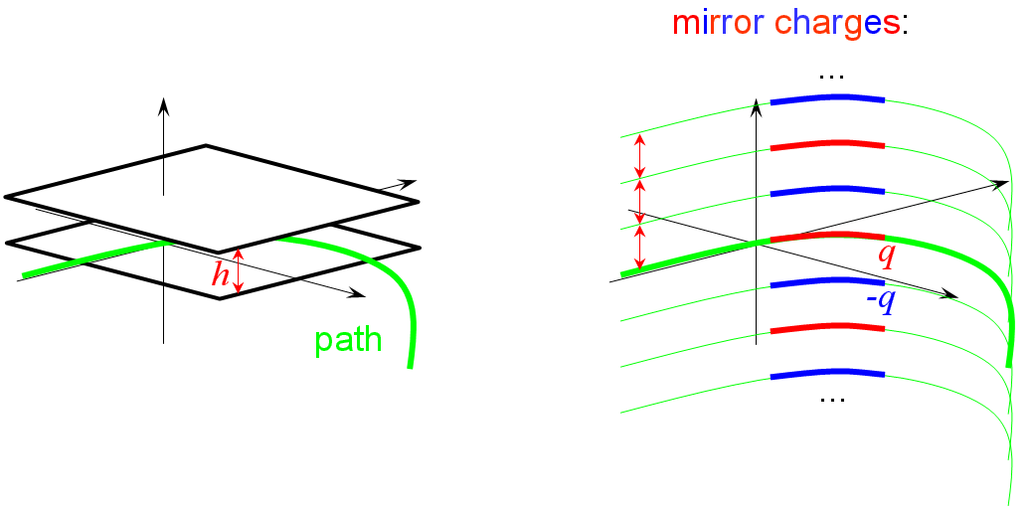
Work in progress: the mesh of the Green’s function is not optimized for wave fronts that are created by mirror charges; therefore the global mesh density is increased. This solution is not optimal concerning mesh resolution and computational efficiency.
Attention: Shielding causes a dispersive propagation of electromagnetic fields; a time grid (see track_step) that works for calculations without shielding is not necessarily sufficient with shielding (and otherwise); it is recommended to observe the particle coordinates and forces at few test particles for all time steps (see online_monitor, type = phase, particle = m) and to adjust the grid if required.

Setting Sub-bunch Sizes from File
Sub-bunch sizes can be defined directly by file. The file name is set with the command
sigma_file = file name
CSRtrack expects an ascii input file with the specified name in the input- or root-directory (see io_path). It reads a list of values for time and dimensions (units = time, length, length, length):
t₁ σ_{||1} σ_{r1} σ_{v1}
t₂ σ_{||2} σ_{r2} σ_{v2}
t₃ σ_{||3} σ_{r3} σ_{v3}
t₄ σ_{||4} σ_{r4} σ_{v4}
...
t_{n} σ_{||n} σ_{rn} σ_{vn}
(Each input line has to start with four numbers, the rest is ignored.) The sub-bunch dimensions are calculated by linear interpolation along the time axis (see track_step, time grid). The interpolated longitudinal dimension is used if the argument file is assigned to sigma_long. Corresponding assignments can be used for the transverse dimensions. The output file created by the steps-monitor (see online_monitor, type=steps) can be used as sub-bunch dimension file, e.g. to perform calculations with exactly the same dimensions a in an earlier run.

Examples
The CSR field of ellipsoidally shaped sub-bunches is calculated with the Green’s function method (csr_g_to_p). The bunch length at different positions along the beam line is read from the file my_file.dat, the horizontal size is fixed and the vertical scales with the vertical size of the beam:
forces{type=csr_g_to_p,
shape=ellipsoid
sigma_file=my_file.dat
sigma_long=file
sigma_rad =0.0003
sigma_vert=relative,relative_vert=1.0
}
If meshed forces and shielding are used, the general format of the forces section will look like this:
forces{type = ...,
sbox = ..., rbox=...,
use_old_mesh = ...,
shield= ..., shield_max=... }

Sections: monitor and online_monitor
- Concept: The monitor section is used to write particles properties and forces before or after a tracking calculation to file while monitors defined in the online_monitor section are served during the tracking. As fields and forces are calculated during the tracking, which is activated in the tracker section, they are undefined before the tracker section has been called.
- monitor section:
identifier | argument | unit / type
name | file name | character string
format | fmt1 / fmt2 / fmt3
The name of the output file is defined by name = file name. The file formats are described below.
- online_monitor section:
identifier | argument | unit / type
name | file name | character string
type | phase / subbunch / steps
format | fmt1 / fmt2 / fmt3
particle | value (m) | integer
start_time_c0 | value (t_{start}) /  now | time / number
start_time_marker | marker name | character string
start_time_shift_c0 | value (dt_{start}) | time / number
end_time_c0 | value (t_{end}) | time / number
end_time_marker | marker name | character string
end_time_shift | value (dt_{end}) | time / number
time_step_c0 | value (t_{step}) /  all | time / number
There are three different monitor types:
type = phase / subbunch / steps
The type phase is used to monitor properties of an individual particle or of the complete distribution.
- Monitor Events: Online monitors are served during the tracking each time when a monitor event is fulfilled. In principle monitor events are defined by the start time t_{start}, end time t_{end} and time step t_{step}, but the so defined monitor grid does usually not coincide with the time grid defined in the section track_step. Therefore monitor events are related always to the next following point on the time grid. t_{start} and t_{end} can be specified either directly by
start_time_c0 = t_{start} / now
end_time_c0 = t_{end}
or by reference to a field boundary with marker:
start_time_marker = marker name
start_time_shift_c0 = dt_{start}
end_time_marker = marker name
end_time_shift_c0 = dt_{end}
The second possibility defines the time relative to the time t_{fb} when the reference particle travels through the field boundary which is specified by marker name:
t_{start} = t_{fb} + dt_{start} and/or t_{end} = t_{fb} + dt_{end}
The time step is defined by
time_step_c0 = t_{step} / all
The argument all has the effect that all points on the time grid are monitored.
- Name convention for output files: Phase monitors of the full particle distribution (type=phase, particle=all) create for each monitor event an individual file. The file name is derived from the argument of the name command and the event number as follows:
name=<string>.<extension>

1st monitor event → file name = <string>0001.<extension>
2nd monitor event → file name = <string>0002.<extension>
3rd monitor event → file name = <string>0003.<extension>
...
The numbering of monitor events depends on the definition of t_{start} and t_{step} that can be defined individually for different monitors. Therefore events with the same number that have been recorded by different monitors do not necessarily coincide.
- Example:
online_monitor{name=x.fmt3,type=phase,format=fmt3,particle=all
start_time_c0=now
end_time_marker=d4b,end_time_shift_c0=1.0
time_step_c0=0.02
}

online_monitor: type=phase
Writes files containing phase space information of all or selected particles.
- format = fmt1 , particle = all: This format is compatible to the corresponding input format of the particles section. The output file can be used as input file for a later (restarted) calculation. Each line of the output file is written with the fortran format (7(1x,e22.15)). The last six numbers in the first line (r₁, r₂, r₃, r₄, r₅, r₆) are set to zero.
- format = fmt2 , particle = all: This format is compatible to the corresponding input format of the particles section. The output file can be used as input file for a later (restarted) calculation. Each line of the output file is written with the fortran format (7(1x,e22.15)). The last six numbers in the first line (r₁, r₂, r₃, r₄, r₅, r₆) are set to zero.
- format = fmt3 , particle = all: Each line of the output file is written with the fortran format (10(1x,e22.15),2(1x,i1)). The output file has the following structure:
t is the time of the distribution. γ_{r} is the Lorentz factor γ that corresponds to the reference momentum (see particles section). σ_{s}, σ_{r}, and σ_{z} are the longitudinal, radial and vertical rms sub-bunch dimensions that were used for the force calculation (see forces section). The particle coordinates (h_{i}, v_{i}, s_{i}) and slopes (h_{i}’, v_{i}’) are defined relative to the reference trajectory and the reference particle: (h_{i}, h_{i}’) are horizontal parameters, (v_{i}, v_{i}’) are the offset and slope in vertical- or z-direction and s_{i} is the path-length difference with respect to the reference particle. δe_{i} is the relative energy deviation normalized to the energy that corresponds to the reference momentum. (f_{s,i}, f_{h,i}, f_{v,i}) are the force components with:
$\begin{aligned}u_{s,i}=p_{i}/p_{i} \\ u_{h,i}=u_{z}×u_{s,i} \\ u_{v,i}=u_{s,i}×u_{h,i} \\ f_{i}=f_{s,i}u_{s,i}+f_{h,i}u_{h,i}+f_{v,i}u_{v,i}\end{aligned}$
In the present version of CSRtrack there is no input format available that allows to set or reset the source and test flags (L_{s,i}, L_{t,i}). Therefore they are always set (=1). The source flag determines if a certain particle contributes to the generation of self-fields or not. A particle is tracked with self and external forces if the test flag is set, otherwise only external fields affect the motion of this particle.

- format = fmt1, particle = m: For each monitor event, a new line with the actual phase space information of particle m is added to the output file. The file is of the following structure:
The first column (t₁, t₂, t₃ …) is the time of the monitor event (unit = time). The next seven rows describe the position, momentum and charge in the same way as for the corresponding input format (fmt1, x_{p}, y_{p}, z_{p}-coordinates). This means the coordinates of the reference particle (m = 1) are absolute, the coordinates of all other particles (m > 1) are relative to the reference particle.
- format = fmt2, particle = m: For each monitor event, a new line with the actual phase space information of particle m is added to the output file. The file is of the following structure:
The first column (t₁, t₂, t₃ …) is the time of the monitor event (unit = time). The next seven rows describe the position, momentum and charge in the same way as for the corresponding input format (fmt2). This means the coordinates of the reference particle (m = 1) are absolute, the coordinates of all other particles (m > 1) are relative to the reference particle (u_{s}, u_{v}, u_{h}-base).
- format = fmt3, particle = m: For each monitor event, a new line with the actual phase space coordinates and forces of particle m is added to the output file. The file is of the following structure:
The first column (t₁, t₂, t₃ …) is the time of the monitor event (unit = time). The next eleven rows describe the position, momentum, charge and force in the same way as for the corresponding input format (fmt3).

online_monitor: type = subbunch
Writes a file containing the sub-bunch dimensions along the beam line.

online_monitor: type = steps
Writes a file containing the (longitudinal) position at the end of each calculation step, the tracking error at this position and the number of tracking iterations.

Appendix

CSRtrack Units
dimension | normalization
length | 1 m
time | 1 m / c₀
momentum | 1 eV / c₀
charge | 1 C
angle | 1 deg

Results for Example Case
Comparison of calculations with force types p_to_p, g_to_p and projected. The data points for force type p_to_p are plotted in red, for g_to_p in blue and for projected in green. Usually the red points are hidden by the blue ones.
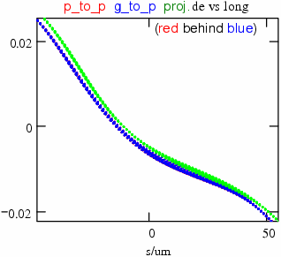

Caption:

Example for Position Averaging Pulse Smoothing Technique
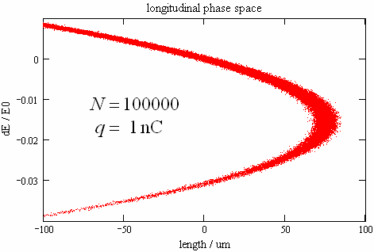
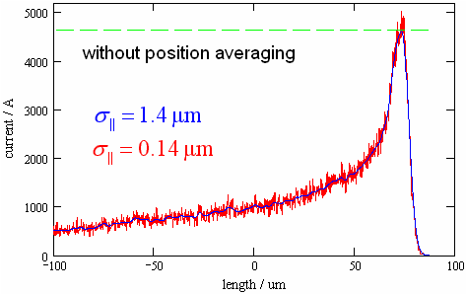
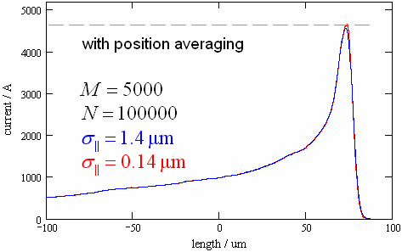

Fixed Bugs
In Version 1.0:
The sub-bunch length for the self-force of type projected was slightly wrong: the longitudinal self-field E_{c||} is calculated as convolution of the longitudinal 1d-current I|| with the CSR-field $E_{σ||/\sqrt{2}}$ of a Gaussian sub-bunch. The 1d-current I|| is computed on an equidistant mesh by substitution of all point particles by sub-bunches of the length $σ_{||}/\sqrt{2}$. By mistake the sub-bunch length for the calculation of $E_{σ||/\sqrt{2}}$ was $σ_{||}$ instead of $σ_{||}/\sqrt{2}$. Therefore the effective sub-bunch length was $\sqrt{1\frac{1}{2}}⋅σ_{||}≈1\text{.}\text{22}σ_{||}$ instead of $σ_{||}$. This has been fixed.

Bibliography
[1] E. Saldin, E.Schneidmiller, M.Yurkov: Radiative Interaction of Electrons in a Bunch Moving in an Undulator. NIM A417 (1998) 158-168.
[2] M. Dohlus: Two Methods for the Calculation of CSR Fields. TESLA-FEL-2003-05
[3] M. Dohlus, A. Kabel, T. Limberg: Efficient Field Calculation of 3D Bunches on General Trajectories. NIM A445 (2000) 338-342.

