T. Limberg, 27.5.2008

ps_viewer User Guide

Version 1.3

Table of Content

Introduction 3
Installation 4
Opening and Plotting a Beam Distribution Data File 5
Slicing the Beam 8
x_nnnn files (special CSRtrack feature) 9
Creating, Editing and Saving Beam Distributions 10
Generating Beam Distributions 10
Editing Transverse Phase Space 10
Editing Longitudinal Phase Space 11
The ‘Option’ Pull-Down Menu 12
Plotting Options 12
General Plotting Options 12
General Plotting Options 13
Mesh Plotting Options 13
‘Subtract Dispersion’ 13

Introduction
A MATLAB GUI called ‘ps_viewer’ is available to plot and analyze phase space distributions. If the MATLAB code is not available on your computer, a compiled version of the ps_viewer can be obtained which runs under a Java environment which is available from MATLAB for free.
As input formats the ps_viewer accepts output files from ASTRA, CSRtrack and elegant. The files can also be saved in the different formats, so format conversion is possible.
New phase space distributions can be generated and existing ones can be edited. Generated bunches are presently restricted to uniform and Gaussian distributions with given length and energy spread, the transverse optics is then set in a second editing step.

Installation
Download the file ‘ps_viewer.zip’ from
http://www.desy.de/xfel-beam/csrtrack/index.html
and extract the files in a folder ‘ps_viewer’.
If the code MATLAB is available, open MATLAB, choose that folder as working directory and enter ‘ps_viewer’ on the MATLAB command line. You should see the following GUI:
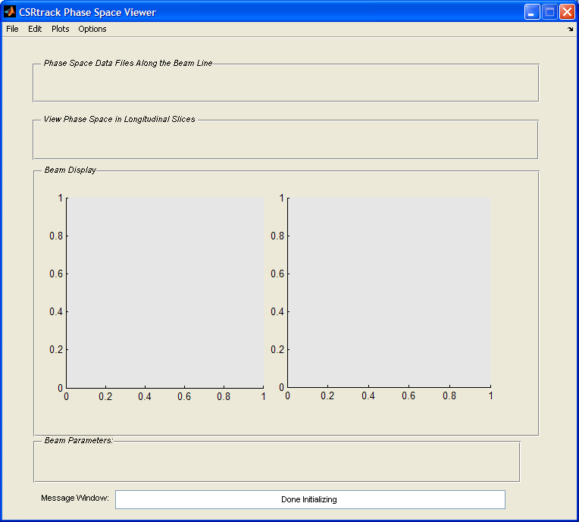

Basically there are two axes to plot phase space projections for comparison. The pull-down menus deal with opening and saving editing data, offer special overview plots etc.
The field below: ‘Phase Space Data Files Along the Beam Line’ refers to a CSRtrack specialty, where the phase space is dumped in regular intervals along the beam line, in a format which is automatically recognized by the ps_viewer.
The field below that: ‘Phase Space in Longitudinal Slices’ is a feature for all file formats which allows plotting beam parameters at different longitudinal positions along the bunch.

Opening and Plotting a Beam Distribution Data File
Use the ‘File’ pull-down menu and choose ‘open’. A browser window appears; go to the phase space file you want to look at. For the first time, it will start in the folder you work in, later it remembers where you’ve been.
CSRtrack files are identified automatically. ASTRA and elegant files can have ambivalent file identifiers, so in case of doubt the code asks you what that is:

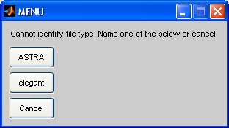

after having identified the file correctly as an ASTRA file, it is read, analyzed, and, to start with, the longitudinal phase space is plotted:

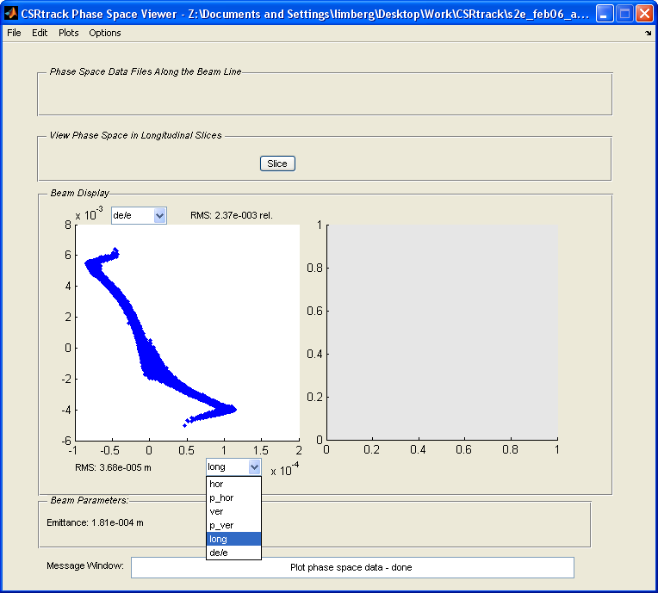

I have opened the horizontal axis coordinate pull down menu to show the basic six phase space coordinates. Since CSRtrack has an absolute Cartesian coordinate system where ‘x’ can easily point along the bunch, hor and p_hor stand for horizontal offset and momentum, ver and p_ver accordingly in the vertical plane, long is the longitudinal particle position in the bunch and de/e its relative energy deviation.
The vertical pull-down menu looks the same, but it offers more choices, if the long coordinate is checked on the horizontal axis:

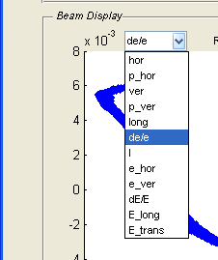 | I: | beam current
 | e_hor: | horizontal emittance (normalized)
 | e_ver: | vertical emittance (normalized)
 | dE/E: | slice energy spread
 | E_long: | longitudinal component of csr field  (CSRtrack only)
 | E_trans: | transversal component of csr field  (CSRtrack only)

To get meaningful results for these quantities, probably the longitudinal slicing parameters have to be adjusted (options pull-down menu, general options, details in chapter ‘Slicing’).
Take note that the pull-down button Slice appears after you loaded a phase space distribution. Buttons and sliders appear and disappear on the ps_viewer panel depending on whether or not you need them.
If you now click on the other, right, window, it will change to white and indicate thereby that it is the active axes. Load the same file into this window and display the horizontal phase space using the pull-down menus of the axes.

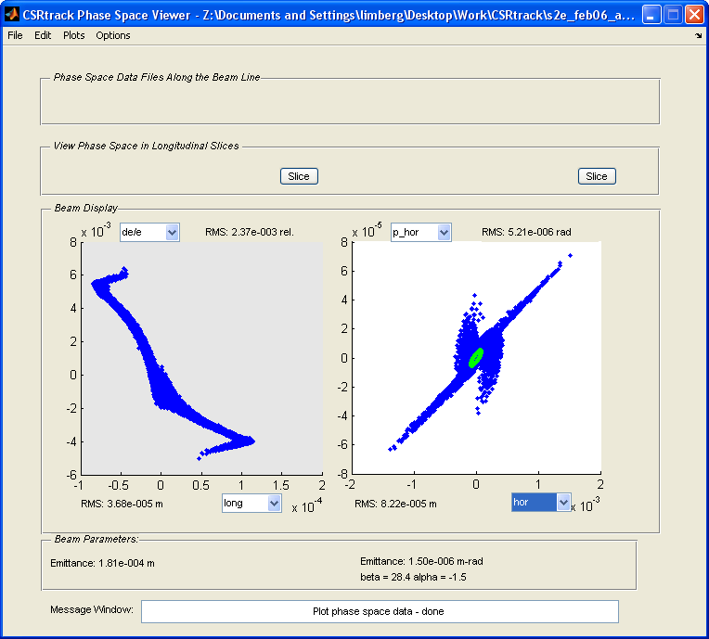

When ‘normal’ transverse phase space (like p_hor vs. hor a.k.a. x-x’) is plotted, the (projected) emittance and the optics is calculated, else only the RMS values. The green line is the usual Twiss parameter ellipse.

Slicing the Beam
When the button ‘Slice’ is pushed, single longitudinal slices are plotted and analyzed. A slider appears where the slice number to be plotted can be chosen.

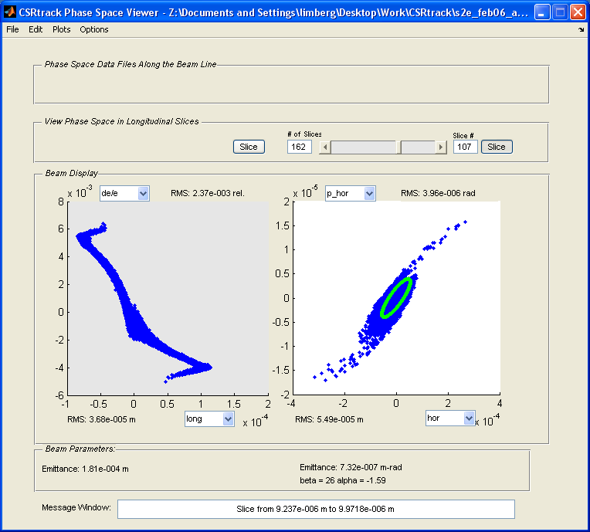

The message window displays the longitudinal positions of the slice boundaries. The slicing is done automatically and can be influenced by editing the ‘General Plot Options’ (‘Options’ pull-down menu -> ’Plotting Options’ -> ‘General Plot Options’, see also chapter ‘Options’).
Slices containing less than 10 particles are not plotted, but generate a warning message.
The program also generates a warning if the default parameters for the slicing lead to having the whole bunch within one slice.

x_nnnn files (special CSRtrack feature)

In the CSRtrack example input file, a so called ‘online monitor’ is specified which dumps the phase space for a given interval (every 10 cm in that case) into files which are named x_nnnn and which file type is fmt3, where nnnn is the number of the file.
If that kind of file is opened by the ps_viewer, it searches the directory for other files of the same kind and, if successful, displays first a message about how many files there are:

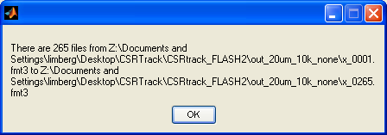

and then the usual phase space plot with a slider where the file-number to be displayed can be chosen.

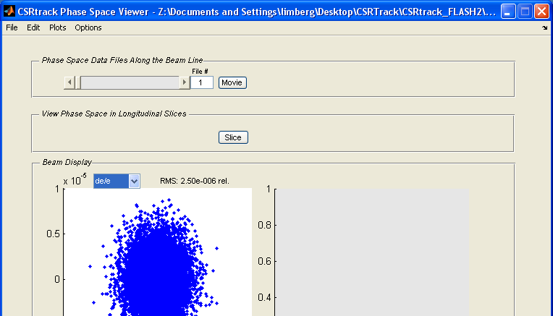

The ‘Movie’ button goes automatically through all the files and plots them one after the other. That can take a while if you track large numbers of particles.

Creating, Editing and Saving Beam Distributions

Generating Beam Distributions
Choose the ‘new’ command in the ‘File’ pull-down menu and the following (hopefully self-explaining) dialog window appears:

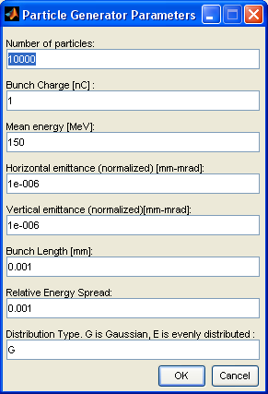

Editing Transverse Phase Space
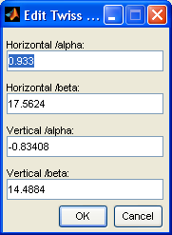
The transverse phase space of the generated bunch has β-functions of 1 m in both planes and the α-values are zero. To change that, choose the ‘Twiss Parameters’ option from the ‘Edit’ pull-down menu. The following (hopefully also self-explaining) dialog window appears, where the Twiss parameters can be adjusted.

Editing Longitudinal Phase Space
Bunch length and uncorrelated energy spread are set at bunch generation. The correlated energy spread, or chirp, can be edited. Choose the ‘RF Chirp’ option from the ‘Edit’ pull-down menu, and a plot of the present longitudinal phase space with a third order fit appears as well as the following dialog box:

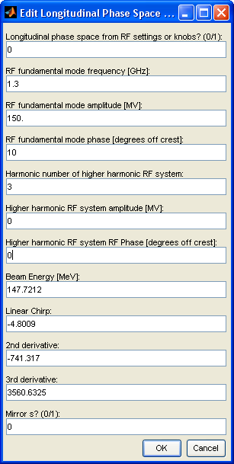

The ‘Option’ Pull-Down Menu

Plotting Options

General Plotting Options
The ‘General Plotting Options’ deal mostly with the slicing (or binning) and smoothing of the longitudinal bunch distribution. The binning can be done equidistant or with a given number of particles per bin. The step size which the program uses to scan the bunch when adding up particles to complete a bin when binning with equal numbers is internally set to sigma/10. That can be changed; useful for instance for extremely spiked distributions with long tails. Note that for instance the peak current is underestimated if the step size or the width of the Gaussian function used for smoothing is too large.

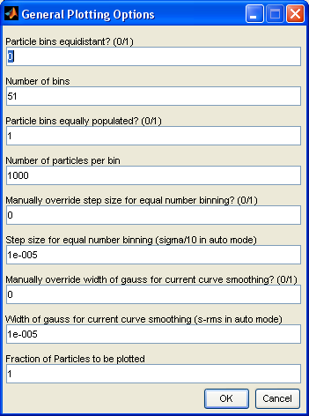

General Plotting Options

Display details of the ‘Summary Plot’ can be adjusted here.

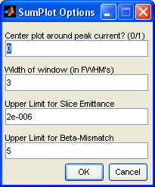

Mesh Plotting Options

Needs work.

‘Subtract Dispersion’

If ‘Subtract Dispersion’ is checked, the correlation between horizontal offset and angle and particle energy is subtracted to second order.
This is a relatively crude method and should be used with care.

